Our City Experiences
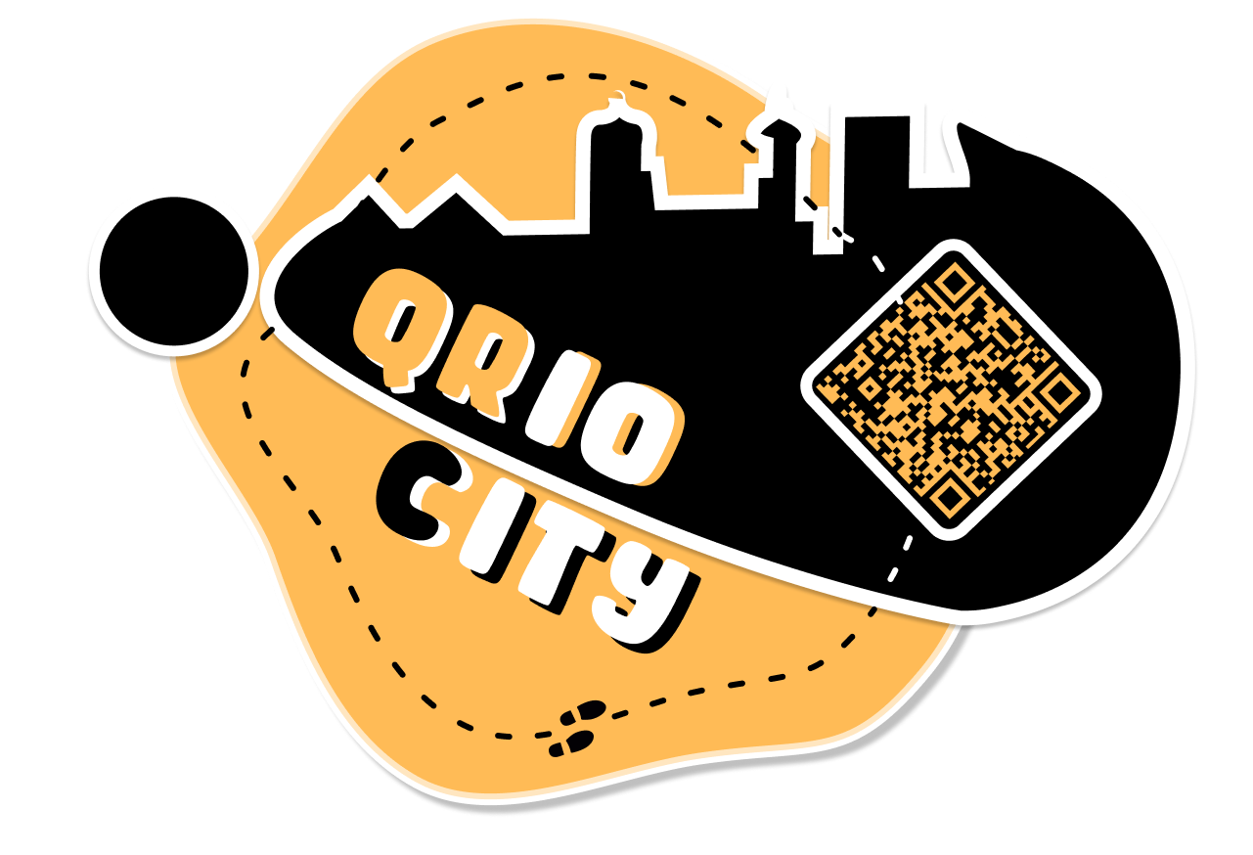

Sponsor
ISEP

Project Summary
The goal is to find the best tourism solution that provides young visitors with an interesting and engaging way to experience the city.
The project requirements are:
- Comply with the following EU Directives:
  - Electromagnetic Compatibility Directive (EMCD);
  - Low Voltage Directive (LVD);
  - Machinery Directive (MD);
  - Radio Equipment Directive (RED);
  - Restriction of Hazardous Substances in Electrical and Electronic Equipment Directive (ROHS);
- Mandatory adoption and use of the International System of Units (The NIST International Guide for the use of the International System of Units)
- Use open source software and technologies.

Participants
Institution: Instituto Superior de Engenharia do Porto
Team N.: 3
Students:
- Jakob Zschocke
- Chloé Herlange
- Anita Pyciak
- Lina Blaschke
- Bram Blauw
Panel of Supervisors:
- Abel Duarte (ajd 'at' isep 'dot' ipp 'dot' pt)
- Jorge Justo (jfj 'at' isep 'dot' ipp 'dot' pt)
- Maria Benedita Malheiro (mbm 'at' isep 'dot' ipp 'dot' pt)
- Maria Cristina Ribeiro (mcr 'at' isep 'dot' ipp 'dot' pt)
- Manuel Silva (mss 'at' isep 'dot' ipp 'dot' pt)
- Paulo Ferreira (pdf 'at' isep 'dot' ipp 'dot' pt)
- Pedro Barbosa Guedes (pbg 'at' isep 'dot' ipp 'dot' pt)

Contents
Project Planning: Deadlines, Tasks, Gantt chart, Task allocation
Logbook: Weekly Report, Meetings, Activities
Report: Report
Deliverables: Links to all deliverables

Contacts
- Jakob Zschocke, 1212301@isep.ipp.pt
- Anita Pyciak, 1212342@isep.ipp.pt
- Chloé Herlange, 1212287@isep.ipp.pt
- Lina Blaschke, 1212313@isep.ipp.pt
- Bram Blauw, 1212284@isep.ipp.pt

Utilities
- DokuWiki Syntax
- Videos on how to use DokuWiki

Acknowledgements
- Sponsor (sponsor)
- Eng.º Vítor Costa Cerqueira, DEE, ISEP (wiki installation and management)
- Prof. João Correia Lopes, DEI, FEUP (wiki template)
— EPS@ISEP Wiki Template 2012-01-15 15:35

