Logbook

Weekly Report

1st Week Report
Discussion about the topic of the project, deciding on 3 top topics.

2nd Week Report (2022/03/03-2022/03/09)
Brief desk-research to compare our experiences with the topic. Narrowing down our problem-statement. Sharing first ideas.

3rd Week Report (2022/03/10-2022/03/16)
We discussed our ideas, we thought about problems that people are facing during the city exploration and we decided to do something that would be fun way of exploring city for individuals or groups. We prepared Global Sprint Plan, Initial Sprint Plan and Gantt Chart. We started writing the “State of Art” chapter.

4th Week Report (2022/03/17-2022/03/24)
We prepared blackbox diagram and identified the features of public display and mobile application/website. After researching, we decided to use QR Codes instead of NFC connections.

5th Week Report (2022/03/24-2022/03/31)
We improved blackbox diagrams accoring to supervisor's comments. We finished “State of the art” section in report. We prepared value proposition for users and customers as well as problem statement. We came up with our team name (dragonics) and logo.
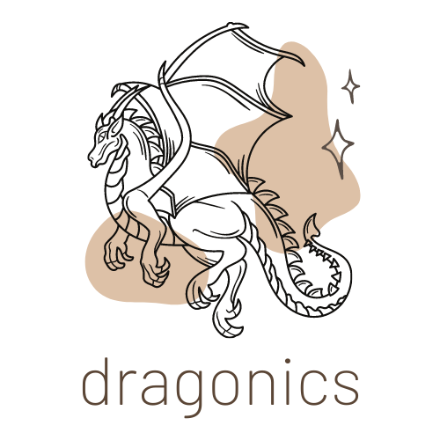

6th Week Report (2022/04/01-2022/04/07)
This week we focused on our design for the public display and our branding. We created mulitple sketches with every component in mind. For communication we created our logos and a first sketch leaflet for advertising our product. We also worked on some managment aspects like stakeholders, risks and so on.

7th Week Report (2022/04/07-2022/04/13)
During this week we precisely pinned down our components for the prototype and started contact with a company to get information about possible public kiosk solutions. We (re)worked the report for the intermediate report. There were a few more logo designs made.

8th Week Report (2022/04/13 -2022/04/28)
During this week we did structural drawings, 3D model with video. We did research on materials, we decided on components for the prototype.

9th Week(s) Report (2022/04/29 -2022/05/12)
During this week we focused on improving the wiki page according to lots of comments from teachers and supervisors. We also improved our 3D model video, making it slower and showing components more closely. We received components for the prototype.

10th Week Report (2022/05/13 -2022/05/19)
We started working on the scientific paper and are close to finishing the rest of the report, other than the chapters about the development. Other than that we looked at different packaging solutions for our product and compared toolboxes for developing our appliction.

11th Week Report (2022/05/20 -2022/05/26)
In this week we started trying out the toolbox we chose for the application development, created a first draft for our poster, made some packaging decisions and designs and wrote more for the report chapters.

12th Week Report (2022/05/27 -2022/06/02)
During this week we worked with Arduino, trying to connect all components. We finished the 3D model video. We finally decided on a toolbox to use to produce an app, we have chosen AppGyver. We started working on User Manual for WebApp, we continued work on the poster.

13th Week Report (2022/06/03 -2022/06/09)
During this week we conducted the first functional test of our prototype. We also worked on WebApp. We did user manual for WebApp. We worked on Wiki and tried to complete it.

14th Week Report (2022/06/10 -2022/06/15)
This week we progressed with work, we made the prototype work. We still work to make WebApp finished, but most of the things are done. We designed 3 versions of the eye-catching poster for the users. We are focusing on finishing Wiki and paper.

Meetings

1st Meeting (2022-03-03)

Agenda:
- Presentation
- Modus operandi
- Project proposals
- Electronic logbook (Wiki)

Minute:
We discussed different topics and chose 3 top ideas that we want to work on. We sent email with our proposals and we got topic “Our city experience”.

2nd Meeting (2022-03-10)

Agenda:
- Present what we did already
- Presentation of identified problems:
  - Explore the city in a fun way, sport, culture, hidden gems
  - Decide what to do, how long does it take, which places to visit
  - Increase comfort – feel comfortable in a city (when moving there or visiting alone)
  - Promote integration – feel integrated (ethnic/cultural minorities, disabled, kids, elderly, women)
  - Facilitate motion – public transport can be confusing
  - Difficulty to find specific things, e.g., sport clubs.

Minute:
We presented our problems to supervisors and got information that we need to do deeper research.

3rd Meeting (2022-03-17)

Agenda:
- Present summary about secondary research
- Presentation of our idea
  - Terminal that will grab attention in public space + app to explore city in fun way
  - Group or individual option
  - Usage of Near Field Communication (NFC) to collect points during exploring the city
  - Cooperation with local suppliers (restaurants, coffee shops, museums, etc.) - advertisement for coupons/discounts
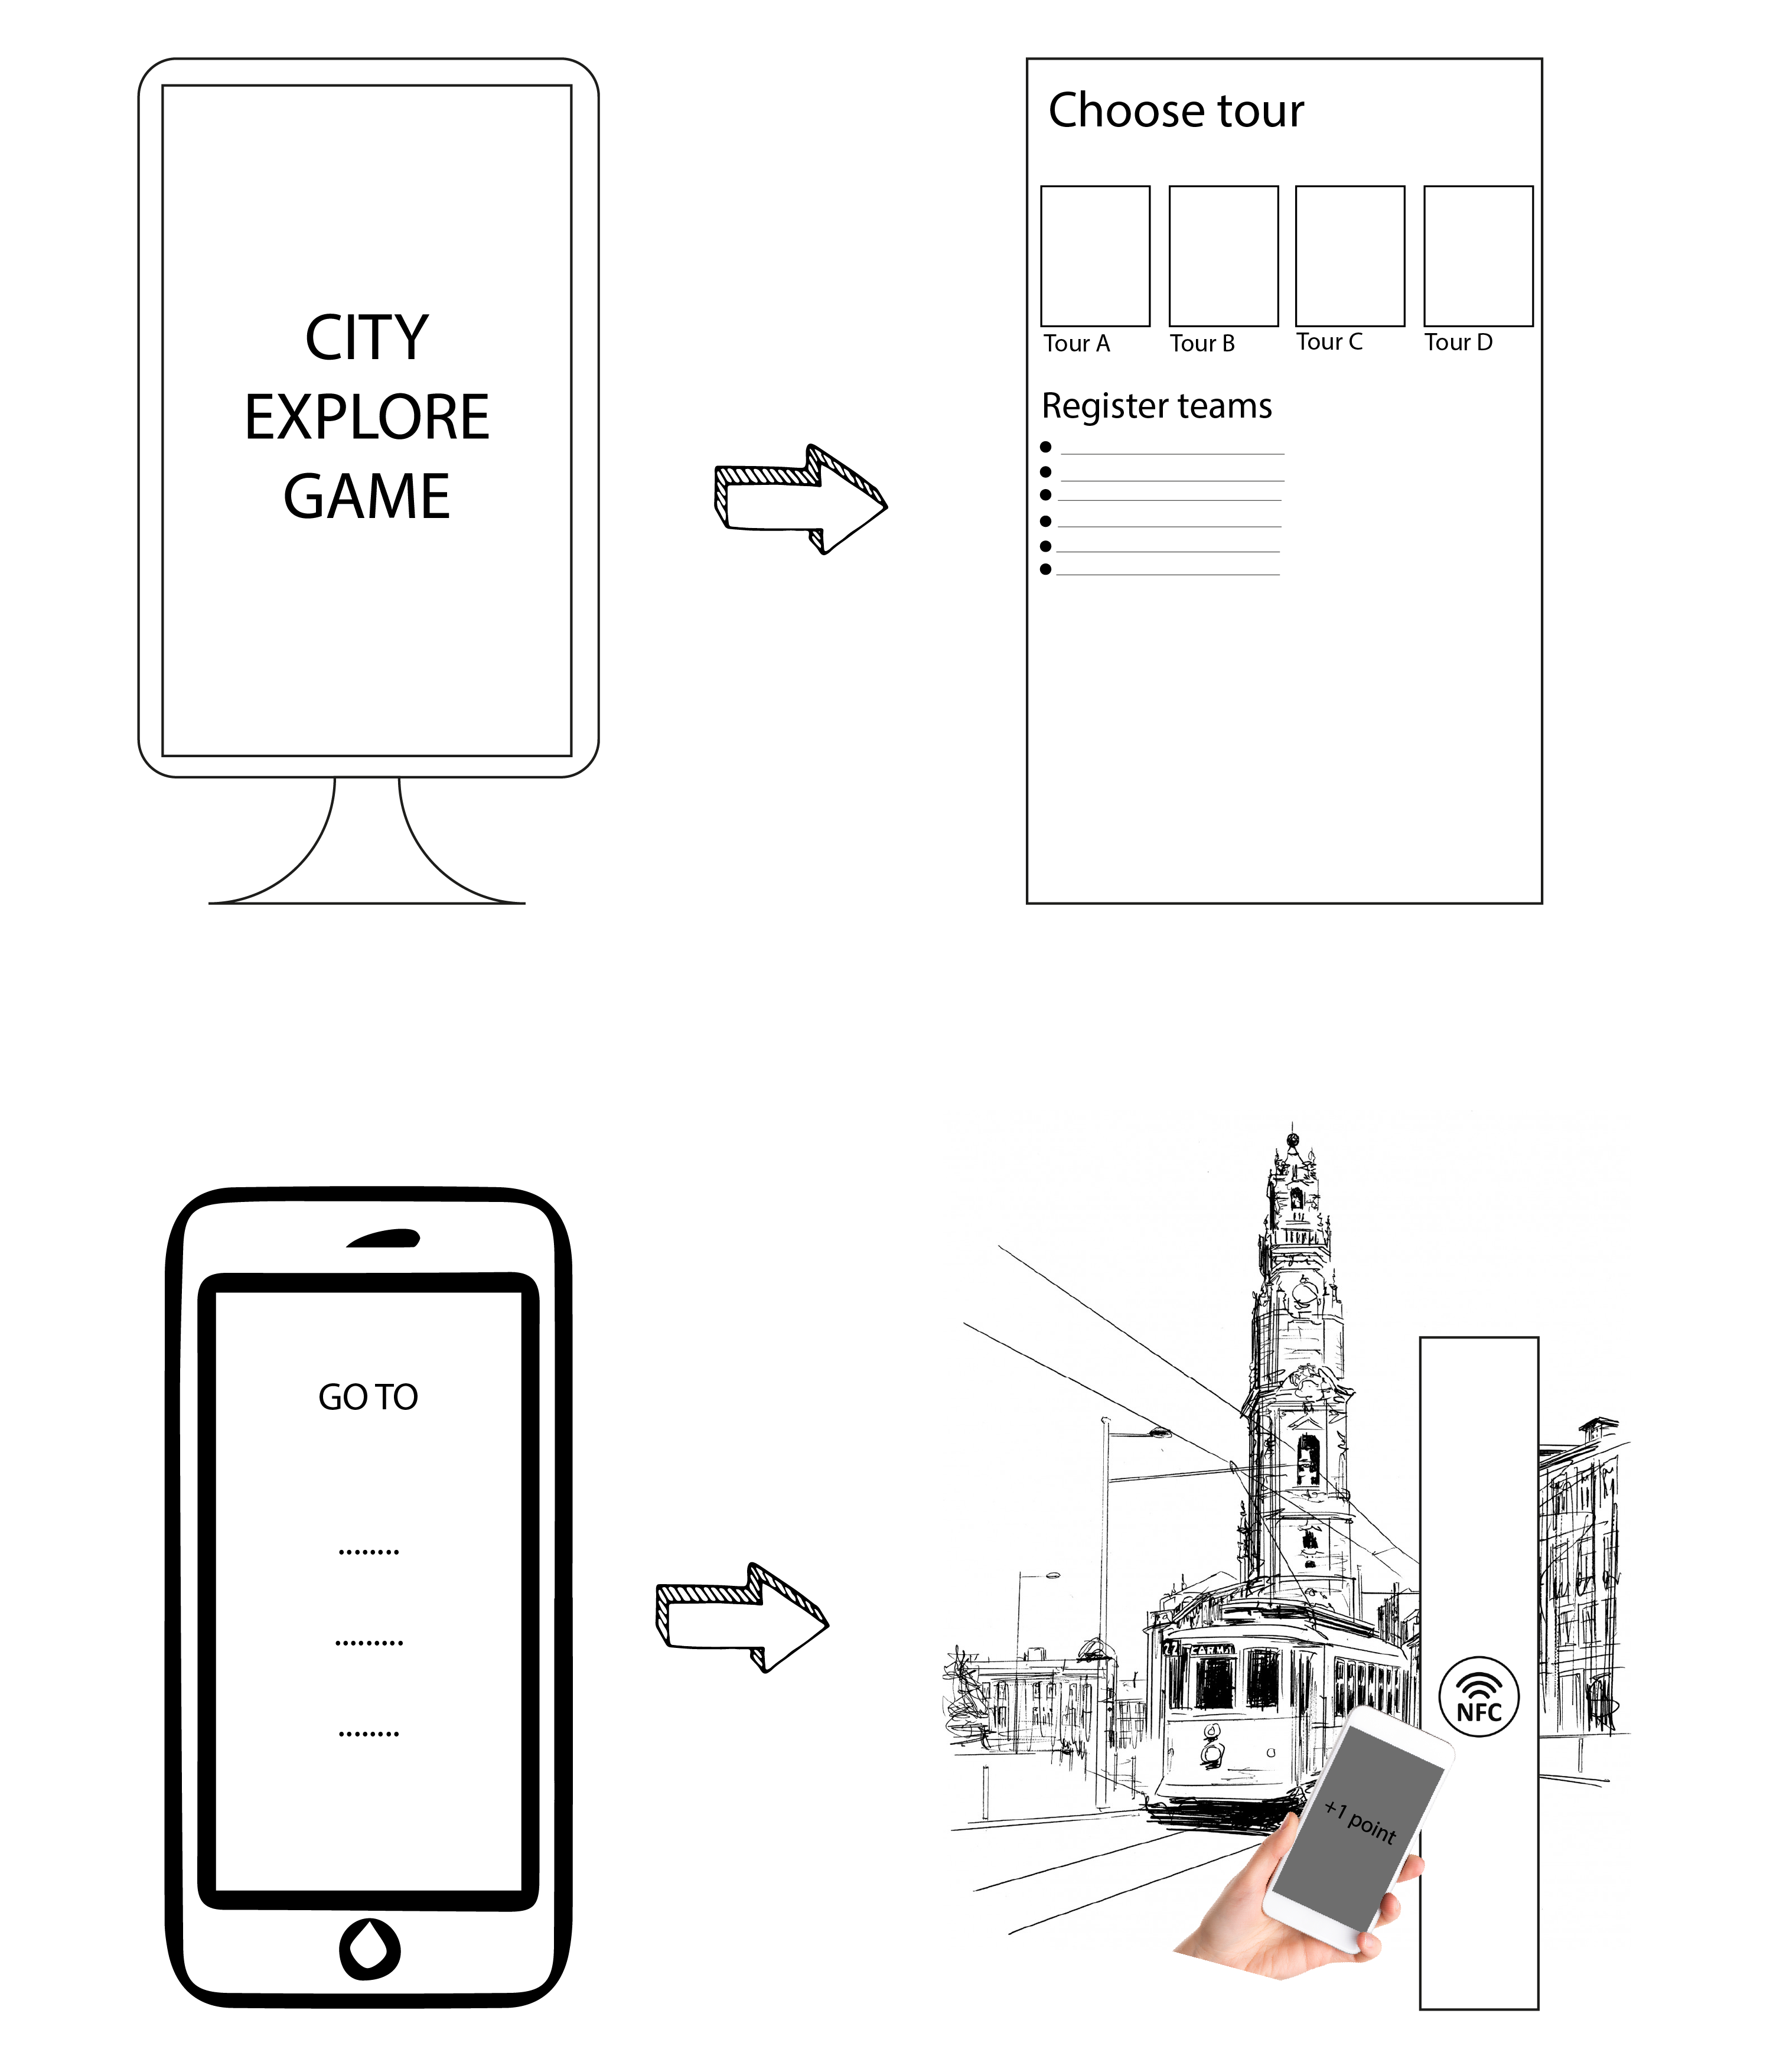

Minute:
Our project idea was presented and accepted. Further instructions were given.

4th Meeting (2022-03-24)

Agenda:
- Quick Response (QR) codes versus Near Field Communication (NFC) - why we decided to work with QR codes
- Mobile vs Web application - what do you think?
- Presentation of our BlackBox Diagram and Functionalities of Application and Public Display
  - What else we should include?
  - Costs
  - Local providers
- Public Kiosk
- Supervisor

Minute:
We discussed our work with the supervisors, we got information that we have to improve our black box diagram and do structural drawings of the public display.

5th Meeting (2022-03-31)

Agenda:
- Improvement of blackbox diagrams
- Designs for public display
- State of the art
- Worked on our brand (Team name, logos, etc…)
- Value proposition for users and customers
- Problem statement for users and customers
- Disscussed further specifics of the application

Minute:
We presented our work and current state. Received positive feedback. Discussed possible design options and next steps.

6th Meeting (2022-04-07)

Agenda:
- More structural designs
- List of components/materials
- Material choice (AES or PE)
- Branding
- Leaflet
- Management aspects (Risks, Stakeholders, …)

Minute:
The product logo was discussed, mixed feedback. List of components should be reworked entirely. Additional comparisson of components.

7th Meeting (2022-04-13)

Agenda:
- More logo designs
- List of components
- SWOT Analysis
- Interim Report

Minute:
We discussed all topics, we get feedback on logo, directions about list of components.

8th Meeting (2022-04-28)

Agenda:
- 3D model, video, structural drawings
- List of components
- Materials for real product
- Prototype - connection of components
- Arduino + speaker + transistor?

Minute:
We discussed all important things and got positive comments on our 3D model video and simulation tests, but we still need to improve it. We discussed connection of components for the prototype.

9th Meeting (2022-05-11)

Agenda:
- Improved 3D model video
- Report improvements according to comments
- Components for prototype

Minute:
Additionally to our already delivered components we recieved some speakers and talked about options for the build. Otherwise we disscussed the schematics, report and next steps.

10th Meeting (2022-05-19)

Agenda:
- Improved 3D model video
- Mycelium packaging
- Toolboxes for web apllication development

Minute:
We recieved feedback for the video, some tipps for the paper writing and information about the next steps, the poster and the manual.

11th Meeting (2022-05-26)

Agenda:
- Toolboxes: Bubble, Backendless, AppGyver…
- Packaging
- Mockups of web app
- Poster
- Working Diagram
- SD-card
Pro-Cons for dev tools
NO-code development tools
Tool | Pros | Cons
Bubble | Beginner friendly; Visual thinking; made for Web-apps; big community/many tutorials; free option not only trial; many-plug ins | free option quite limited (e.g. no API in free version); just one editor in free version, unsure about how free version compares
App Gyver | Freeer than bubble; more advanced than bubble | not as big of a community
Backendless | complex | rather complex, not very beginner friendly

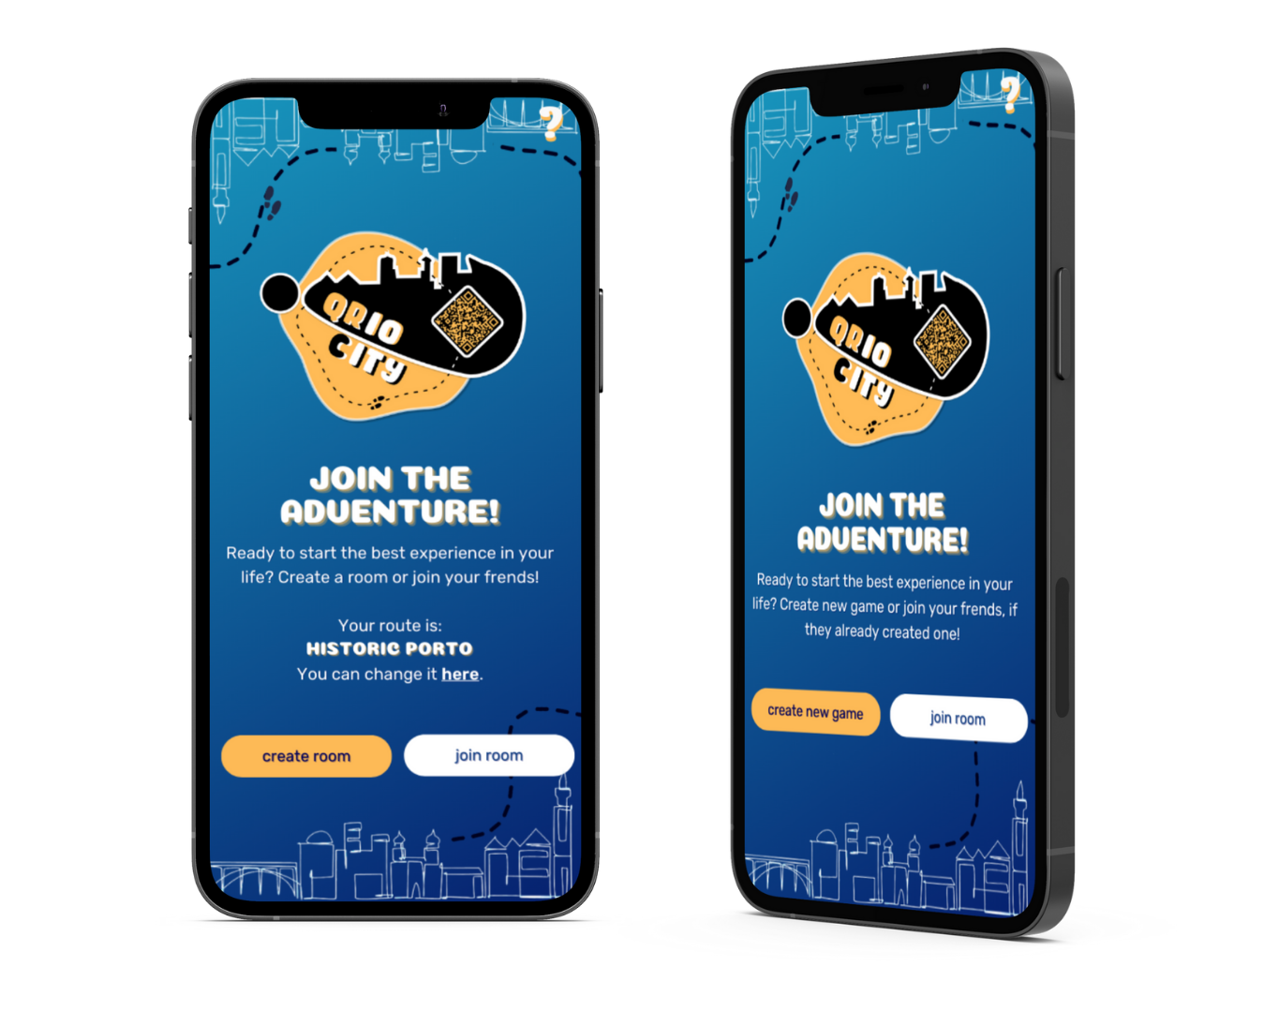
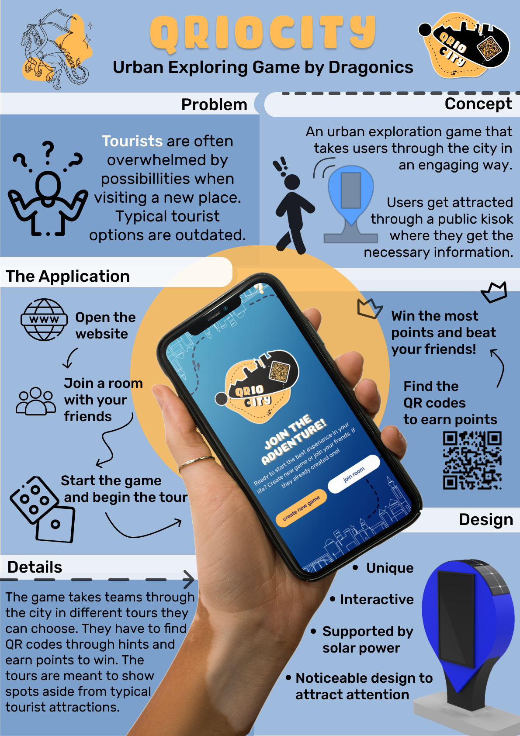

Minute:
We discussed toolboxes and their functionalities. We decided to use AppGyver. We need to add some more information about the material into the Packaging section of the report.

12th Meeting (2022-06-02)

Agenda:
- Technical progress/questions
- 3D Final Video
- AppGyver
- Functional Tests?

Minute:
We discussed problems with the connection of components for our project. We presented a 3D video, but still, there are some small improvements that have to be done. We presented AppGyver as our choice for the toolbox, it was accepted by supervisors. We had some questions how the Functional Tests should look like.

13th Meeting (2022-06-09)

Agenda:
- First functional test
- WebApp progress
- User manual for WebApp

Minute:
We discussed our work and got positive feedback. We need to implement small change to user manual, but in general it's okay. We need to focus this week on paper and finishing WebApp.

13th Meeting (2022-06-15)

Agenda:
- Work update
- Eye-catching poster
- Presentation - questions
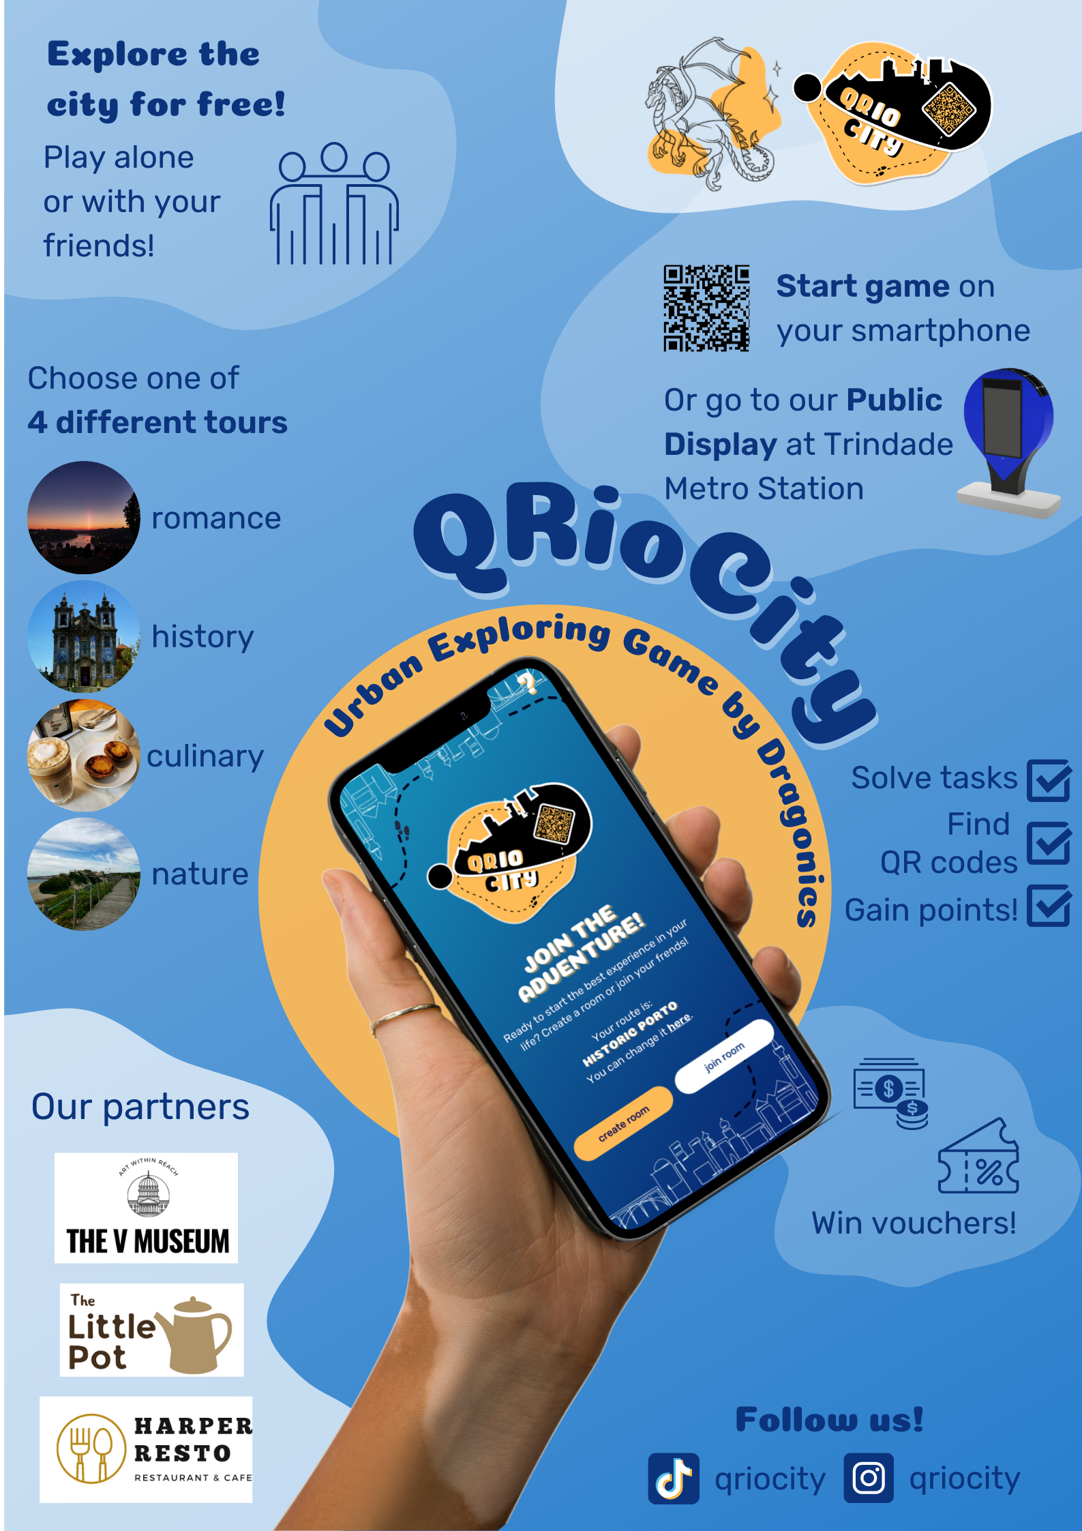
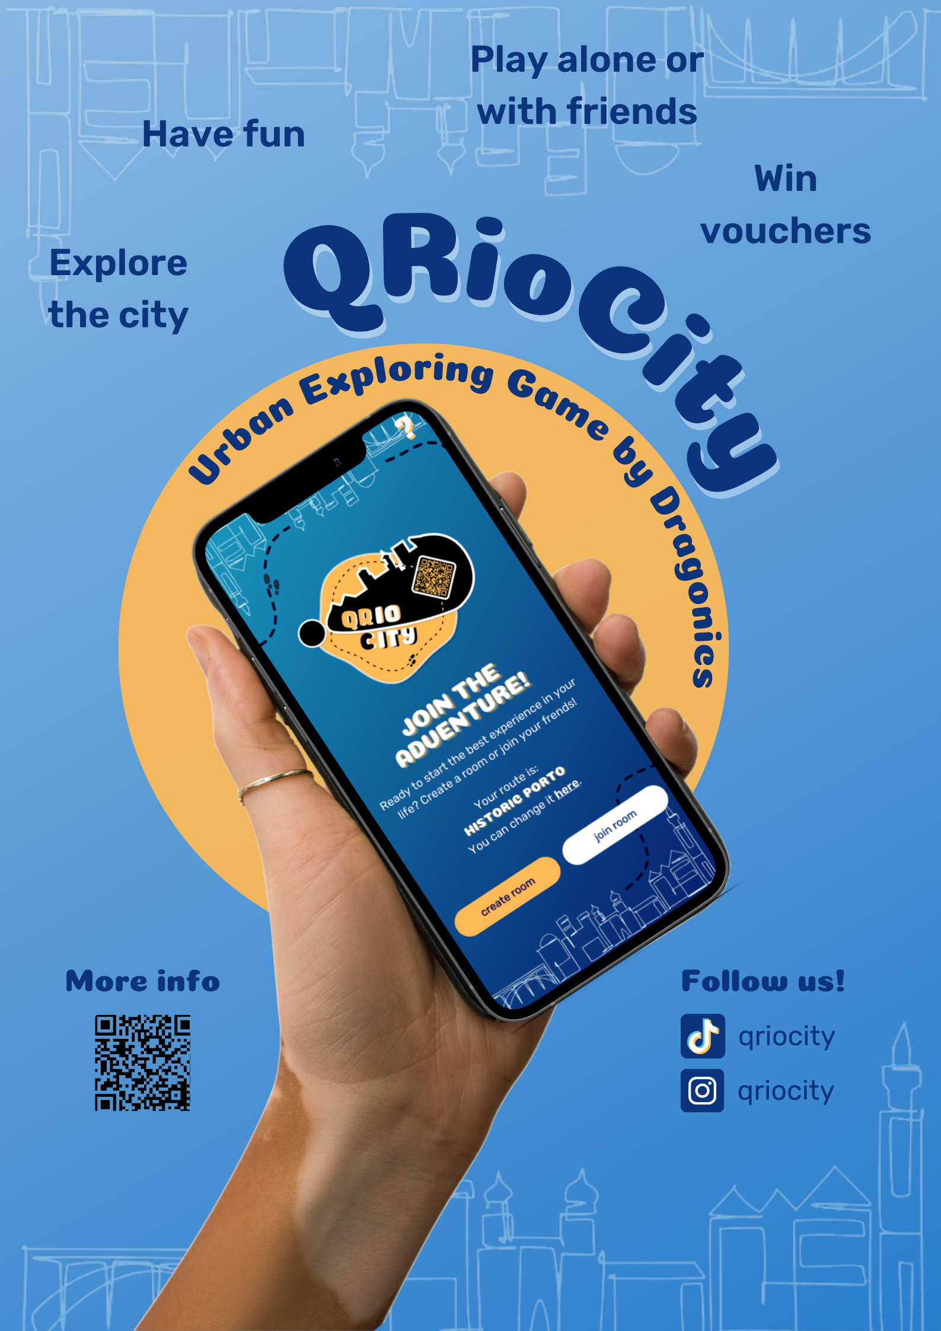
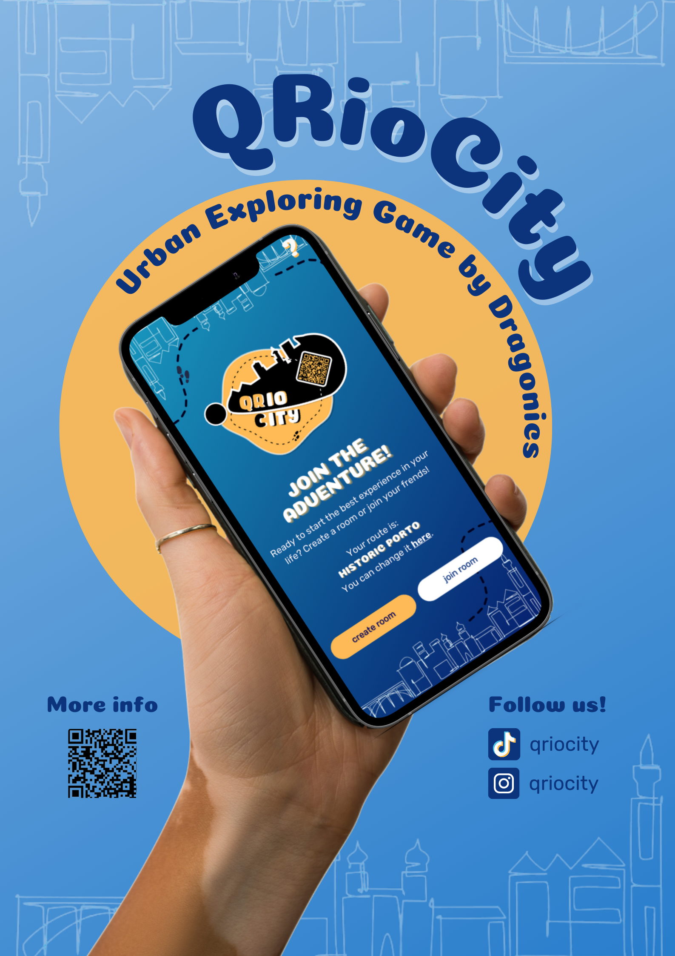

Minute:
We were talking about the progress we made, we got some comments about the paper. Posters are accepted, but small changes have to be introduced. We asked few questions about presentation to be sure what to include.

